# DATAFLOWDIAGRAM&USERSTORIES

|  |  |
| --- | --- |
| DATE | 15 OCT 2022 |
| TEAM ID | PNT2022TMID02102 |
| PROJECT NAME | Smart farmer - IOT enabled smart farming application |
| MAXIMUM MARKS | 4 Marks |

**Data Flow Diagram:**

The classic visual depiction of how information moves through a system is a data flow diagram (DFD). A tidy and understandable DFD may visually represent the appropriate quantity of the system demand. It demonstrates how information enters and exits the system, what modifies the data, and where information is kept.

1. Get the inputs from different sensors such as Moisture Sensor, Humidity Sensor, Temperature Sensor. Data from the sensors are given as inputs to the microcontroller - Arduino or Raspberry Pi
2. Data are feed into the cloud storage using wi-fi module.
3. MQTT-Message Queuing Telemetry Transport Protocol is used to order data in FIFO fashion.
4. App is Used to create our own to IOT software according to our specifications where we can able to monitor and control the device.

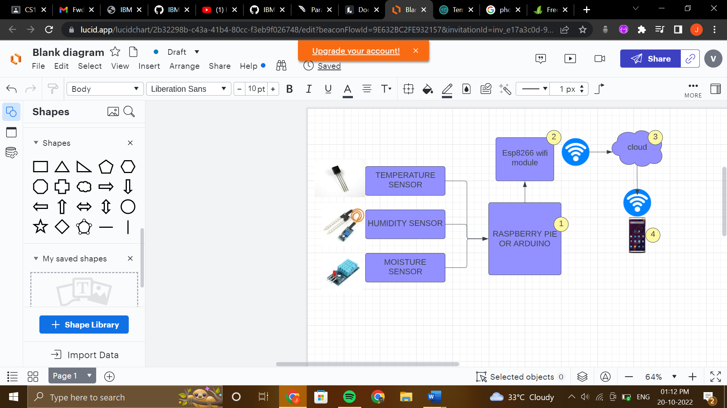

# User Stories

|  |  |  |  |  |  |  |
| --- | --- | --- | --- | --- | --- | --- |
| **User Type** | **Functional Requirement (Epic)** | **User Story Number** | **User Story / Task** | **Acceptance criteria** | **Priority** | **Release** |
| Customer (Mobile user) | Registration | USN-1 | As a user, I can register for the application by entering my email, password, and confirming my password. | I can access my account / dashboard | High | Sprint-1 |
|  |  | USN-2 | As a user, I will receive confirmation email once I have registered for the application | I can receive confirmation email & click confirm | High | Sprint-1 |
|  |  | USN-3 | As a user, I can register for the application through G-mail | I can receive confirmation email & click confirm to login | Medium | Sprint-1 |
|  | Login | USN-4 | As a user, I can log into the application by entering email & password |  | High | Sprint-1 |
| **User Type** | **Functional Requirement (Epic)** | **User Story Number** | **User Story / Task** | **Acceptance criteria** | **Priority** | **Release** |

|  |  |  |  |  |  |  |
| --- | --- | --- | --- | --- | --- | --- |
|  |  | USN-5 | If I forgot my password or username, I can reset it again through my email | I can receive reset Mail to the registered Email Id | High | Sprint-2 |
| Customer (Web user) | Registration | USN-6 | As a user, I can register by entering my email, password, and confirming my password | I can access my account / dashboard | High | Sprint-2 |
|  |  | USN-7 | As a user, I will receive confirmation email once I have registered for the application | I can receive confirmation email & click confirm | High | Sprint-2 |
|  |  | USN-8 | As a user, I can register for the application through G-mail | I can receive confirmation email & click confirm to  login | Medium | Sprint-2 |
|  | Login | USN-9 | As a user, I can log into the application by entering email & password |  | High | Sprint-2 |
|  |  | USN-10 | If I forgot my password or username, I can reset it again through my email | I can receive reset Mail to the registered Email Id | High | Sprint-3 |

|  |  |  |  |  |  |  |
| --- | --- | --- | --- | --- | --- | --- |
| **User Type** | **Functional Requirement (Epic)** | **User Story Number** | **User Story / Task** | **Acceptance criteria** | **Priority** | **Release** |
| Customer Care Executive | Help | USN-11 | If I have any doubt in using application or web, I can clarify it by clicking Help option in the dashboard. |  | High | Sprint-3 |
| Administrator | Feedback | USN-12 | I Can give my feedback about the application and I can post my queries. | I can receive acknowledgement | Low | Sprinit-4 |